ASSIGNMENT 1

A) C++ Program to Check Whether Number is Even or Odd

**Program:**



b) C++ Program to Check Whether a character is Vowel or Consonant.

**Program:**

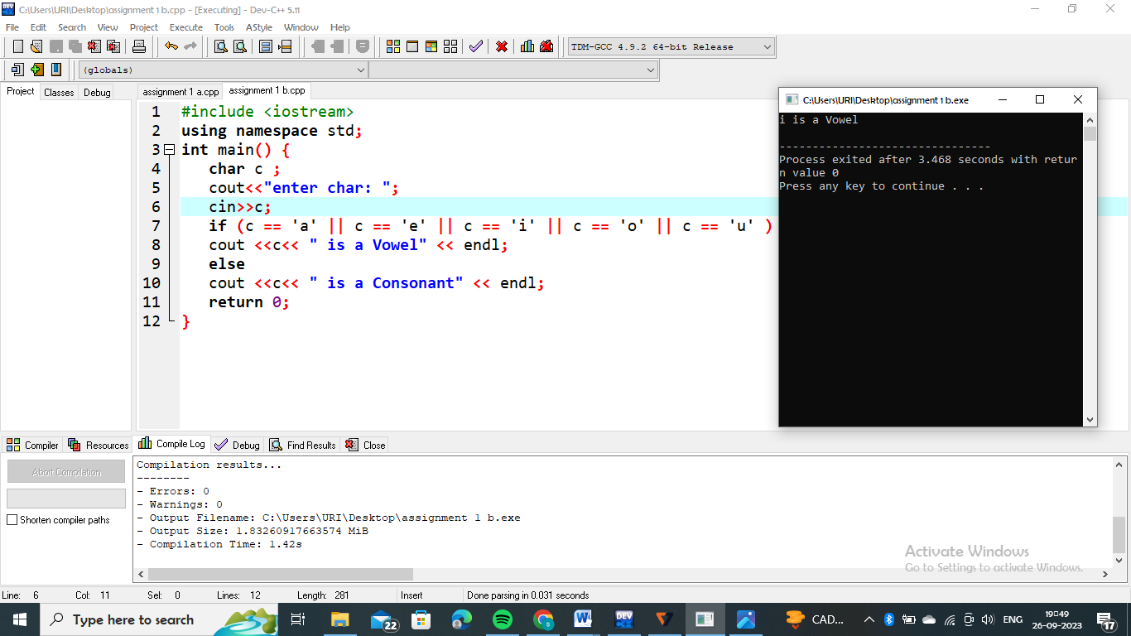

c) C++ Program to Find Largest Number Among Three Numbers

**program:**

